Two-Network DHCP Relay Lab Notes
October 2, 2026
One DHCP server (SRV2) can hand out addresses to both networks. It serves its own side directly, and the far router relays the other side’s requests to it with ip helper-address. Solved on Oct 2, 2026. The last blocker was a Cisco detail: SRV2 runs router software, so it ignored ip default-gateway until it got a default route.

At a glance
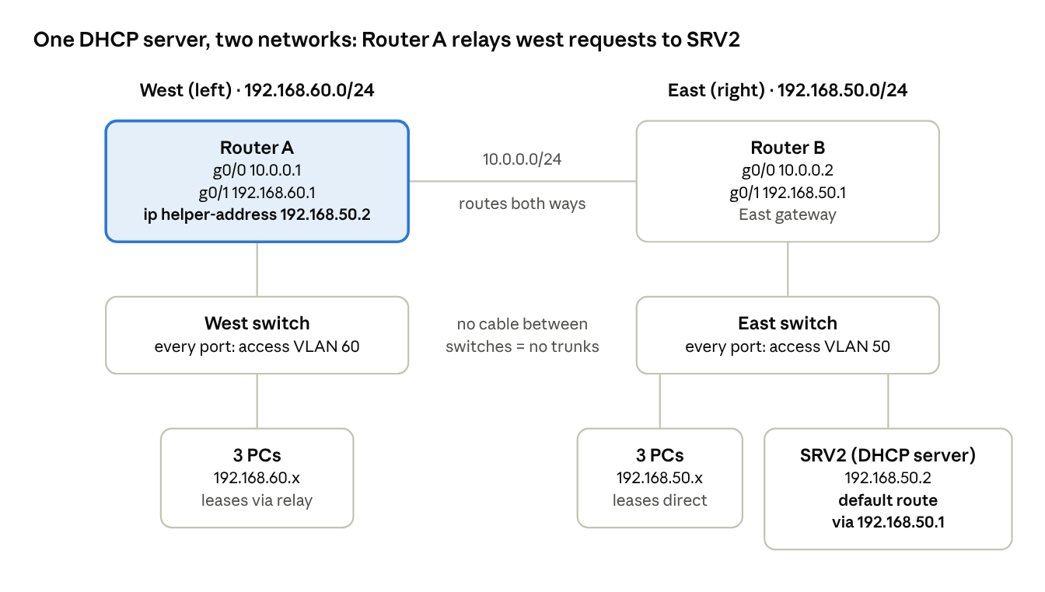
Lab topology: Router A west, Router B and SRV2 east
Each side is its own network. The switches aren’t cabled together, so only the routers connect the two sides, and Router A forwards the west side’s DHCP requests to SRV2.

The final fix
SRV2 had ip default-gateway 192.168.50.1 set, but Router A still couldn’t reach it. SRV2 runs Cisco IOS, the same software as a router, and IOS ignores ip default-gateway on a device that routes. That command only works on devices that don’t route, like a switch. A routing device needs a default route instead:
ip route 0.0.0.0 0.0.0.0 192.168.50.1
Check it with show ip route on SRV2: it should say Gateway of last resort is 192.168.50.1. Without it, SRV2 could answer its own side but had no way to send replies to the west side.

Problems and fixes
Most issues came down to a typo, a port left shut down, or a tool built for a different job. Listed in the order we hit them.
# | What we saw | Cause | Fix
1 | Lab step didn’t check off after show vlan brief | Ran it from user mode (SW1>) after typing exit. On real gear, exit from # logs you out | Run show commands from # mode. Leave config mode with end, or use do show ... inside it
2 | ipconfig /release said no adapter was in a permissible state | The PC had a static IP, so DHCP was off | netsh interface ipv4 set address name="eth0" source=dhcp, then ipconfig /renew
3 | Tried netsh interface ipv6 set interface eth0 routerdiscovery=disabled | Wrong tool: it controls IPv6 router discovery, not IPv4 DHCP | Used the IPv4 command from row 2
4 | Router ports said “administratively down”; CDP showed 0 neighbors | Router ports start shut down, and CDP only talks over links that are up | no shutdown on each port
5 | West router g0/1 had 192.168.5.1 | Typo: should have been a 192.168.x.x network address | Corrected the address (final: 192.168.60.1)
6 | Lab flagged MISSING_TRUNK, so we trunked office switch g0/1 | Wrong tool: there’s no switch-to-switch cable, so nothing needs a trunk | Set g0/1 back to an access port
7 | switchport mode trunk gave “Invalid input detected” | Typo (“witchport”) or not inside the interface yet | Check the prompt shows (config-if)#. switchport ? lists valid options
8 | ping ... source g0/1 on the switch: “A source IP address is required” | Ran on a switch. Switch ports are Layer 2 and have no IP | Ping from a router
9 | ping ... source g0/1 on the router: “Invalid IP address” | The lab doesn’t support the source option | Plain ping 192.168.50.2
10 | Router couldn’t ping SRV2 (.....) | Static route typo: 92.168.50.0 instead of 192.168.50.0. The first no ip route also deleted the wrong line | no ip route 92.168.50.0 255.255.255.0 10.0.0.2, then add the 192 route
11 | Lab flagged DHCP_NO_SERVER_REACHABLE: srv2 not reachable in VLAN 50 | VLAN 50 on each side is a separate network, and routers stop DHCP broadcasts | DHCP relay (ip helper-address) on the west router
12 | Fixes kept going to the wrong router | East and west got flipped while troubleshooting | Settled the layout once: A = left/west, B = right/east with SRV2
13 | The router next to SRV2 had g0/1 = 192.168.60.1 | The LAN addresses were on the wrong routers | Router B g0/1 = 192.168.50.1, Router A g0/1 = 192.168.60.1
14 | Pinged 192.168.50.0 and got no reply | .0 is the network’s own address; no device can have it (.255 is broadcast) | Ping a real device: .1 is the gateway, .2 is SRV2
15 | Router A had S 92.168.50.0 and S 192.168.50.0 via 10.0.0.1 | Old routes left over after re-addressing. The second pointed at Router A’s own address | Deleted both with no ip route ..., then ip route 192.168.50.0 255.255.255.0 10.0.0.2
16 | SRV2’s switch port (g0/7) started out in VLAN 1 | It wasn’t moved when the other ports went into VLAN 50 | switchport access vlan 50 on g0/7
17 | Router A still couldn’t ping SRV2, even with ip default-gateway set on SRV2 | SRV2 runs Cisco IOS and routes, so it ignores ip default-gateway | ip route 0.0.0.0 0.0.0.0 192.168.50.1 on SRV2. This was the final fix

Trunking, the wrong tool
Trunks only matter on a cable between two switches. This lab’s two networks are joined by routers, and VLAN tags never cross a router, so trunking couldn’t connect them.
- Access port: carries one VLAN. Use it for PCs, servers, and a router port on a single-VLAN network.
- Trunk port: carries many VLANs over one cable, tagging each frame with its VLAN number (802.1Q). Use it switch to switch, or on one router cable that carries several VLANs (router-on-a-stick).
- A trunk on a PC port breaks it. The PC lands in the native VLAN (VLAN 1) instead of its real VLAN.
- VLAN numbers are local. VLAN 50 on one switch and VLAN 50 on a switch behind another router are different networks.
- A Layer 3 switch wouldn’t fix it either. It stops DHCP broadcasts at the network edge just like a router, so it still needs a pool or ip helper-address.
What actually lets one server reach both sides is the DHCP relay, covered next.

The fix: one server, two networks
SRV2 sits on the east side and serves it directly. West PCs reach it through a DHCP relay on Router A.
How a west PC gets an address:
- The PC broadcasts a DHCP request.
- Router A’s g0/1 catches it and, because of ip helper-address 192.168.50.2, forwards it to SRV2 as a normal routed packet.
- SRV2 sees the request came through 192.168.60.1 and answers from its 192.168.60.0 pool.
- The reply travels back through Router B and Router A to the PC.
This needs a route on each router to the other side’s network, and a default route on SRV2. Keep one DHCP source per network: no DHCP pools on the routers.

Final IP plan
Device | Port | Address | Role
Router A (west) | g0/0 (to Router B) | 10.0.0.1/24 | Router link
Router A (west) | g0/1 (to west switch) | 192.168.60.1/24 | West gateway, relays DHCP to SRV2
Router B (east) | g0/0 (to Router A) | 10.0.0.2/24 | Router link
Router B (east) | g0/1 (to east switch g0/8) | 192.168.50.1/24 | East gateway
SRV2 | g0/0 (to east switch g0/7) | 192.168.50.2/24 | DHCP server, default route to 192.168.50.1
East PCs | east switch g0/1–g0/3 | 192.168.50.21–254 | Pool LAN
West PCs | west switch | 192.168.60.21–254 | Pool “east” (the 192.168.60.0 pool), via relay
SRV2’s 192.168.60.0 pool is named “east” even though it serves the west. Pool names are only labels, so it works; rename it to WEST if you want it to read clearly.

Final config by device
Router A (west)
conf t
hostname a
interface g0/0
ip address 10.0.0.1 255.255.255.0
no shutdown
interface g0/1
ip address 192.168.60.1 255.255.255.0
ip helper-address 192.168.50.2
no shutdown
exit
ip route 192.168.50.0 255.255.255.0 10.0.0.2
end
Router B (east)
conf t
hostname b
interface g0/0
ip address 10.0.0.2 255.255.255.0
no shutdown
interface g0/1
ip address 192.168.50.1 255.255.255.0
no shutdown
exit
ip route 192.168.60.0 255.255.255.0 10.0.0.1
end
Switches: every port is an access port, with no trunks. East switch: g0/1–g0/3 (PCs), g0/7 (SRV2) and g0/8 (Router B) in VLAN 50. West switch: the PC ports and Router A’s port in VLAN 60.
interface g0/X
switchport mode access
switchport access vlan 50
SRV2
conf t
interface g0/0
ip address 192.168.50.2 255.255.255.0
no shutdown
exit
ip default-gateway 192.168.50.1
ip route 0.0.0.0 0.0.0.0 192.168.50.1
ip dhcp excluded-address 192.168.50.1 192.168.50.20
ip dhcp excluded-address 192.168.60.1 192.168.60.20
ip dhcp pool LAN
network 192.168.50.0 255.255.255.0
default-router 192.168.50.1
dns-server 1.1.1.1
exit
ip dhcp pool east
network 192.168.60.0 255.255.255.0
default-router 192.168.60.1
end
The ip route 0.0.0.0 0.0.0.0 192.168.50.1 line is what made it work. ip default-gateway alone is ignored on SRV2.

Checklist
Routing between the sides works. The last checks are on the west side.
- ☒ Router A and Router B addresses and routes match the IP plan
- ☒ Router A: ping 10.0.0.2 (link to Router B)
- ☒ Router A: ping 192.168.50.2 (reaches SRV2 across the routers)
- ☒ SRV2: both pools, gateway and default route
- ☒ East switch: g0/1–g0/3, g0/7 and g0/8 in VLAN 50
- ☐ West switch: PC ports and Router A’s port are access ports in VLAN 60, no trunks
- ☐ West PC: ipconfig /renew, then ipconfig /all shows 192.168.60.x, gateway 192.168.60.1, DHCP Server 192.168.50.2
- ☐ SRV2: show ip dhcp binding lists the west PC

Useful commands
Two habits caught most mistakes: check the prompt before typing, and verify every IP or route with a show command right after entering it.
Command | Run on | What it tells you
show vlan brief | Switch | Which ports are in which VLAN. Trunk ports aren’t listed
show interfaces g0/X switchport | Switch | One port’s mode (access or trunk) and VLAN
show interfaces status | Switch | Each port’s state and VLAN, or “trunk”
show interfaces trunk | Switch | Trunk state and which VLANs are allowed and active
show cdp neighbors | Switch or router | What’s plugged into each port. Only up links; PCs don’t appear
show ip interface brief | Router | Each port’s IP and status. You want up/up
show ip route | Router | C = connected, L = own IP, S = static. No matching line means the packet is dropped
show ip dhcp pool | DHCP server | Pool range and how many addresses are leased
show ip dhcp binding | DHCP server | Which MAC address got which IP
ipconfig /all | PC | IP, gateway, DHCP Enabled, and which DHCP server answered. A 169.254.x.x address means no DHCP server replied
ping <IP> | Router or PC | ! = reply, . = timeout

